**Smart Faucet (Water Tap)**

**The idea:**

Making a Smart Faucet is operating with your hands without touching any point of the tap if you would open it so it’s easy to use cold, hot water or mixing them.

No more bacteria on your hands after you have washed them.

This is schematic for my project (R_Smart Faucet).

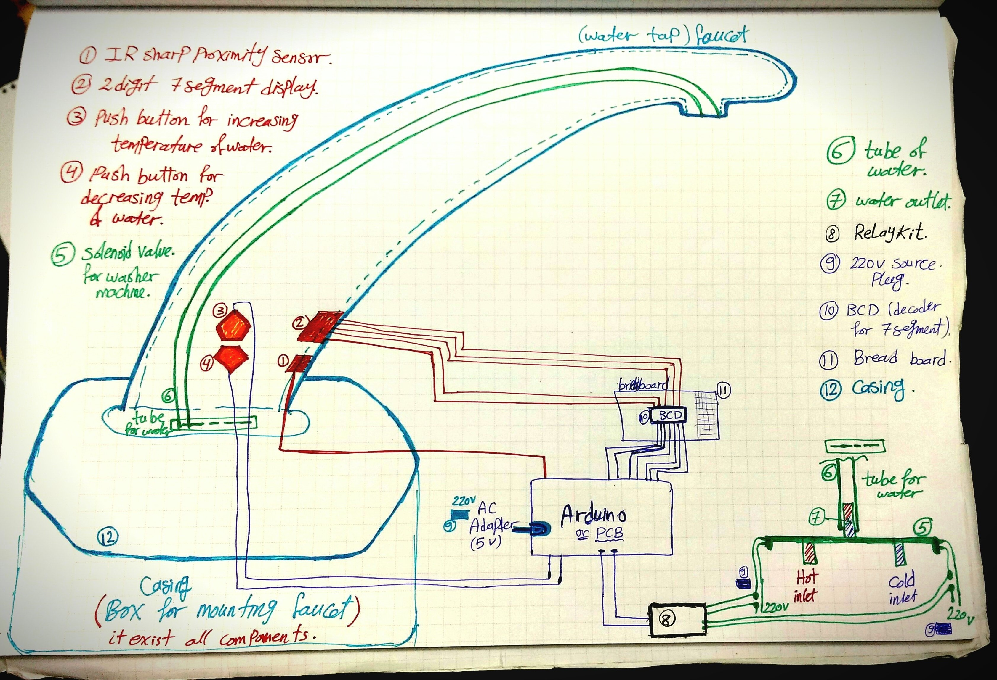

**The Objectives & Business Opportunity:**

Hygienic solution that no diseases, more bacteria or viruses can spread

Save money on water bills and energy consumption

Water conservation of up to 70 %

Easy to Maintain and Service

Easy to use, easier to install

Low cost

***Business Opportunity:***

Home (Kitchens or Bathrooms)

Schools/Universities

Commercial/Public

Hospitals/Healthcare centers

**BOM (Bill of Materials):**

Sharp IR Proximity and Range Finder Sensor (10-80 cm)

AC Adapter (Adjustable)

Solenoid Valve for washing machine with two inlet water and one outlet water

Flexible hose or (flexible tube for outlet water)

Pull flexible hose for washing machine to inlet water (Quantity 2)

Arduino Uno

2-Channel 220V-10A 5V Relay

BCD (74LS49) to 2 digit 7 segment common cathode decoder driver

2 digit 7 segment display common cathode 10 pins only

Push button (Quantity 2)

Connecting wire with 220v (Quantity 2)

Breadboard

Jumpers (male-male and female-male)

PLA for 3D printer

Resistors

Plywood 3mm thickness

Screws 3mm diameter

**Mechanical Design:**

I liked this idea because I suffered from closing and opening the water tap completely when my hands are oily or not clean or soap on it.

First I designed the smart faucet on CATIA-V5. I made a pocket through the side for push buttons and the front for 7 segment and sharp IR proximity sensor then do the opening for flexible hose or (flexible tube for outlet water)

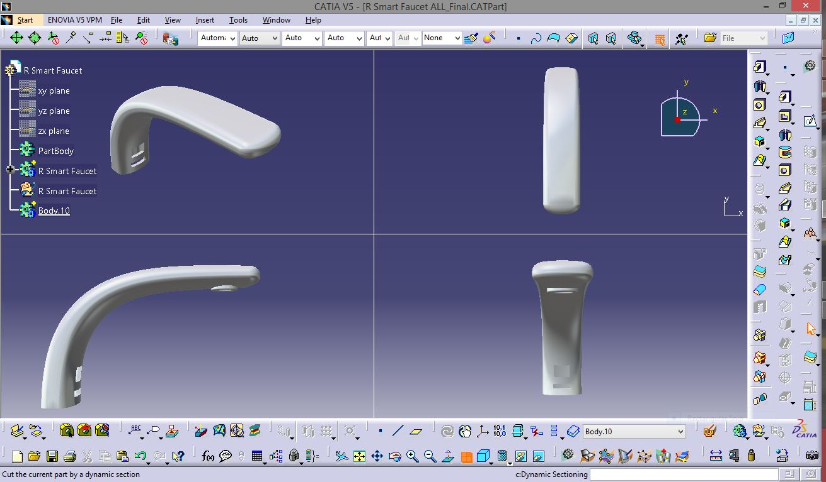

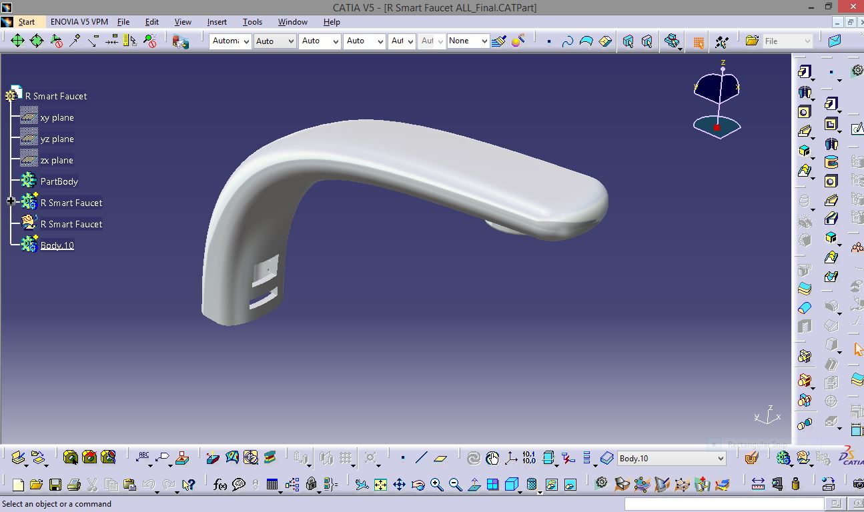

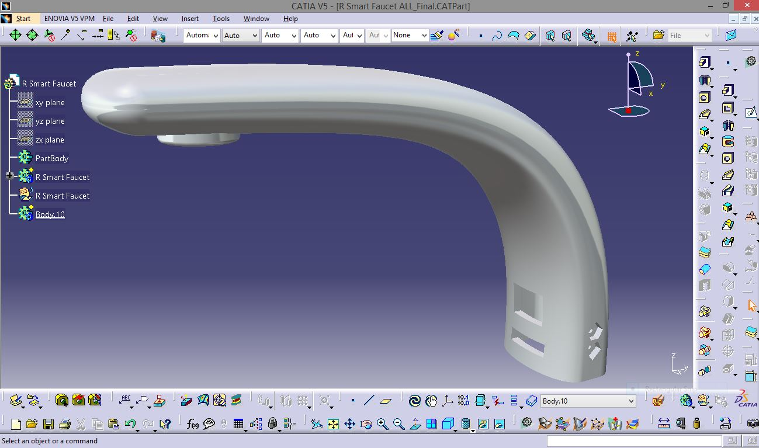

**Before 3D printing for smart faucet,** I apply a primer as shown below to get smooth surface finish then I painted it with black color.

The push buttons mounts with sharp IR proximity sensor bracket with the box for mounting faucet as a casing is simple box on CATIA-V5.

After that, I manufactured box for mounting faucet on laser cutting machine and smart faucet, push buttons mounts and sharp IR proximity sensor bracket on 3D Printer

So now the all designs are assembled them together.

For this stage, the Smart Faucet is functional and the parts are press fit exactly according to my design on CATIA-V5. I need to design the circuit.

**Electronics:**

For the Electronics part I will need to do the following:

Sharp IR proximity sensor to detect the presence of hands within the range that I specified i.e. 200 mm.

Microcontroller board as an Arduino Uno kit to read the IR sensor and control the solenoid valve with two inlet for hot/cold water and single outlet for mixed water, 2 digit 7 segment, relay kit and push buttons to increase or decrease temperature of water as you need by controlling the signals to relay kit then show the required temperature on 2 digit 7 segment display common cathode.

This first video illustrated that sharp IR proximity sensor control on opening/closing relay kit then all electronics connections for smart faucet in the second video.

I connected 2 digit 7 segment display as shown below:

**Programming:**

I programmed my project with Arduino Uno kit by connecting it to my laptop (Power on test).

***Code explanation***

The sharp IR proximity sensor is connected to analog pin, so when the sharp IR proximity sensor sense your hands the signal will send to open relay then open solenoid valve and the 7 segment will show the required temperature. So I wrote a simple function to read the IR and return the value.

int irDetect()

{

int val=analogRead(IR);

if (val<=threshold)

{

return 1;

}

else

{

return 0;

}

}

int checkButtons()

{

if(digitalRead(buttonUp)==1)

{

return 1;

}

else if(digitalRead(buttonDown)==1)

{

return 2;

}

else

{

return 0;

}

}

void relayOut(int temp)

{

float val = (temp - norm);

if (val >=0)

{

cold-=(val/5)*42.5;

}

else

{

hot-=(val/5)*42.5;

}

analogWrite(relayHot, hot);

analogWrite(relayCold, cold);

}

The next step I will want to control the Relay kit and solenoid valve with PWM. PWM initialize to initialize the PWM registers to start solenoid valve which connected to 220v and relay kit then relay kit will open and close quickly to get the required temperature that I will control by push buttons UP/DOWN.

Value = (required temp – normal temp)

Cold - = (value/5)*42.5)

Hot + = (value/5)*42.5)

i.e. 42.5 = Step = 255/6

Finally, this is the whole Arduino code and the main loop is a master loop that integrated all components together with 2 digit 7 segment display.

#include <sevenSegmentDisplay.h>

byte seven_seg_digits[10][7] = {

{

1,1,1,1,1,1,0 }

, // = 0

{

0,1,1,0,0,0,0 }

, // = 1

{

1,1,0,1,1,0,1 }

, // = 2

{

1,1,1,1,0,0,1 }

, // = 3

{

0,1,1,0,0,1,1 }

, // = 4

{

1,0,1,1,0,1,1 }

, // = 5

{

1,0,1,1,1,1,1 }

, // = 6

{

1,1,1,0,0,0,0 }

, // = 7

{

1,1,1,1,1,1,1 }

, // = 8

{

1,1,1,1,0,1,1 } // = 9

};

#define threshold 200

#define norm 40

float cold =255;

float hot=255;

float temp=40;

const int firstDigit = 3;

const int secondDigit=4;

const int pinA = 6;

const int pinB = A1;

const int pinC = A2;

const int pinD = A3;

const int pinE = A4;

const int pinF = A5;

const int pinG = 2;

const int buttonUp=8;

const int buttonDown=9;

const int relayHot=10;

const int relayCold=11;

const int IR=A0;

void setup()

{

pinMode(2, OUTPUT);

pinMode(3, OUTPUT);

pinMode(4, OUTPUT);

pinMode(5, OUTPUT);

pinMode(6, OUTPUT);

pinMode(7, OUTPUT);

pinMode(8, INPUT);

pinMode(9, INPUT);

pinMode(10, OUTPUT);

pinMode(11, OUTPUT);

pinMode(12, OUTPUT);

Serial.begin(9600);

}

void loop()

{

digitalWrite(12, HIGH);

int sens = irDetect();

if(sens)

{

relayOut(temp);

}

else

{

analogWrite(relayCold,0);

analogWrite(relayHot,0);

}

int sens2=checkButtons();

//delay(20);

if(sens2==1)

{

temp+=5;

}

else if(sens2==2)

{

temp-=5;

}

int fDigit = int(int(temp) % 10);

int sDigit=int(temp/10.0);

displayNum(fDigit, 1);

delayMicroseconds(5);

//delay(20);

displayNum(sDigit, 2);

delayMicroseconds(5);

//delayMicroseconds(1);

//delay(100);

Serial.print("Temp ");

Serial.println(temp);

//displayNum(4,1);

}

void displayNum (int num, int digit)

{

Serial.print("IN ");

Serial.print(num);

Serial.print(" ");

Serial.println(digit);

if (digit==1)

{

digitalWrite(firstDigit, LOW);

digitalWrite(secondDigit, HIGH);

}

else

{

digitalWrite(firstDigit, HIGH);

digitalWrite(secondDigit, LOW);

}

analogWrite(pinA,seven_seg_digits[num][0]*255);

analogWrite(pinB,seven_seg_digits[num][1]*255);

analogWrite(pinC,seven_seg_digits[num][2]*255);

analogWrite(pinD,seven_seg_digits[num][3]*255);

analogWrite(pinE,seven_seg_digits[num][4]*255);

analogWrite(pinF,seven_seg_digits[num][5]*255);

digitalWrite(pinG,seven_seg_digits[num][6]*255);

}

int irDetect()

{

int val=analogRead(IR);

if (val<=threshold)

{

return 1;

}

else

{

return 0;

}

}

int checkButtons()

{

if(digitalRead(buttonUp)==1)

{

return 1;

}

else if(digitalRead(buttonDown)==1)

{

return 2;

}

else

{

return 0;

}

}

void relayOut(int temp)

{

float val = (temp - norm);

if (val >=0)

{

cold-=(val/5)*42.5;

}

else

{

hot+=(val/5)*42.5;

}

analogWrite(relayHot, hot);

analogWrite(relayCold, cold);

}

**Business Model:**

**What’s NEXT (Business Development):**

I would like to make bathrooms and kitchens with complete features like smart soap dispenser, smart door, smart shower and smart toilet flusher so you will be able to control anything just with your hands without touch anything.

Then I will develop this design and control to manage open, close and hot, cold water without touch any point of the faucet so you can now direct the power of water just like an orchestra. Just a smooth gesture to do all you want with water.

Furthermore, I will design fancy and smart product to open any existing normal faucet (water tap) and convert any existing faucet to Smart Faucet.

**Applications:**

Home (Kitchens or Bathrooms)

Schools/Universities

Commercial/Public

Hospitals/Healthcare centers

**Features:**

Easy to use, easier to install

Water conservation of up to 70 %

Low cost

Save money on water bills and energy consumption

Easy to Maintain and Service

Hygienic solution that no diseases, more bacteria or viruses can spread

**Files:**

**References:**

<https://grabcad.com/library/damixa-theremin-ceron>